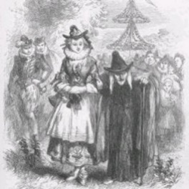
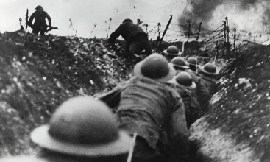
Year 6 Spring Term

Happy New Year!
This term we have two exciting thematic topics planned for our conflict focus – ‘Wars of the World’ and ‘Pendle Witches’. We also have our sights set firmly on SATs preparations; so much of the work will prepare children to successfully tackle this challenge.
Maths  Within Maths, learning will continue to have a heavy focus on number, in particular decimals and percentages. We will also cover Measurement, Statistics and geometry, with problem solving and reasoning being incorporated where possible to ensure that all children are confident with these types of questions. As ever, we will continue with a strong focus on times tables practice but would encourage the use of this at home also! Children will have arithmetic sessions to provide the basic calculation and mental skills, which are important and necessary for the arithmetic SATs test.  English  English learning will have a strong focus on the required standard at the end of Year 6 – children will continue to write sentences with ambitious vocabulary and punctuation, whilst manipulating sentences for effect. Children will be encouraged to use a variety of higher-level punctuation to make sentences more varied and interesting for the reader. They will be writing at length this term, creating more detailed pieces of writing that culminate all skills they have learned in KS2. We will start our English by writing short narratives based on the animation ‘Alma’ and writing letters from the perspective of a soldier in the trenches.  Science  In science, we will focus on Animals including Humans, which focuses on the human body, the circulatory system and the impact of drugs, exercise, alcohol and lifestyle. The children will have plenty of opportunity to deepen their scientific enquiry skills through investigations throughout this topic.  Religious Education  The children will continue to learn about the community and the various religions that make up our local area. | Topic  In spring 1, our topic “Wars of the World” is a thematic unit, based on conflicts past and present, with a key focus on history and geography. Pupils will learn about the root causes of war and have an understanding of  its impact, focusing on the two World Wars in particular. They will also learn about civil wars and pacifism. In spring 2, our topic ‘True Crime? The  Pendle Witches’ is an investigative-style unit focusing on the events leading up to, and the trials of, the Pendle Witches in 1612.  Reading  The children will be building on their comprehension skills focusing on the main question types in preparation for their SATs paper. They will be completing a mixture of comprehension questions and SATs style questions.  P.E  Year 6 PE sessions will be on Tuesdays and Thursdays. Please ensure your child has a full PE kit and all clothing is clearly labelled.  MFL  Modern Foreign Languages will focus on French. Children will continue to build upon conversational French as well as beginning to describe family members and hobbies.  PSHEe  In spring 1, we will focus our attention on belonging in a community and media literacy/digital resilience, followed by in spring 2 learning about money and work. Children will have plenty of opportunity to  discuss scenarios and learn about the world around them.

