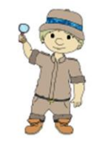
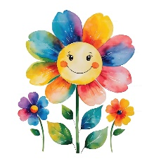
Palmers Cross Reception Spring Term 2026
Welcome back.    Welcome back after the Christmas break. We hope that you had an enjoyable and restful time. This Spring term we will begin with our new topic, ‘Let Us Play’, before moving on to ‘Jurassic Park’. We will use these themes as a basis for planning across all areas of the curriculum wherever possible. Through ‘Let Us Play’, the children will explore different types of play, toys old and new, how toys work, and how to play cooperatively with others. They will develop their communication skills, practise turn-taking, explore materials to design and make their own toys, and use imaginative play to build stories and role-play scenarios. As we move into ‘Jurassic Park’, the children will learn about dinosaurs, fossils and the prehistoric world. They will explore simple scientific concepts such as comparing sizes, learning about herbivores and carnivores, and discovering how fossils are formed. We will also be learning about different celebrations, including Chinese New Year and Easter. Our learning takes place through a mix of adult-led and child-initiated sessions, both indoors and outdoors, and the children help to guide our learning wherever possible. | Literacy  Children will build upon their Autumn phonic knowledge and continue learning new phonemes as well as being introduced to new helpful words. Children will continue to consolidate their learning from Phonics into their Literacy work by developing their writing skills through practising letter formation, word building and beginning to write sentences. The children will continue to be supported in their reading through whole class story time, whole class reading and individual reading.
Mastering Number
As mathematicians in Reception, the children will continue
developing their understanding of numbers to 10 through
subitising and composition. They will practise counting in
different patterns and will recognise numbers in their
written form. They will begin to learn number bonds to 5
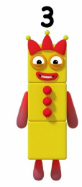
and 10 and recall number facts.
Much of our mathematical work will be practical, using
apparatus such as cubes and small toys. The children will
also learn about 3D shapes and will make comparisons
between different measures.
Physical Development  Children receive two taught sessions of PE each week but have daily access to our outdoor classroom, allowing their gross motor skills to be refined. The children will also improve their fine motor skills by taking part in daily fine motor activities such as cutting and threading. | Personal, Social and Emotional Development  Through PSHE lessons and all areas of the Early Years curriculum, children will develop their skills surrounding managing themselves, self-regulation and building relationships. As well as separate PSHEe lessons, children will use stories and Circle Time to explore their thoughts, feelings and emotions.
Homework
Children will continue to be asked to read at home each week in order to support their progress in school we will continue to send words home weekly linked to their prior phonics learning.
Communication and Language
Communication and Language Across the curriculum, children will develop their speaking, listening and attention and understanding skills. They will listen attentively to stories, learn to follow instructions accurately and will learn to express themselves appropriately.

